TITLE

A PROJECT REPORT
Submitted by

Narendra Kumar RA2211026020001
Arun Vembu RA2011026020015
Madhav RA2011026020018

Under the guidance of

Dr. C. Saravanan
Assistant Professor
Department of Computer Science and Engineering
with Specialization in Cloud Computing

in partial fulfillment for the award of the degree of

BACHELOR OF TECHNOLOGY
in
COMPUTER SCIENCE AND ENGINEERING
with specialization in
CLOUD COMPUTING

of
FACULTY OF ENGINEERING AND TECHNOLOGY



SRM INSTITUTE OF SCIENCE AND TECHNOLOGY RAMAPURAM, CHENNAI - 600089

May 2026
SRM INSTITUTE OF SCIENCE AND TECHNOLOGY
(Deemed to be University U/S 3 of UGC Act, 1956)

BONAFIDE CERTIFICATE

Certified that this project report titled “Code Crackers - Interactive coding platform with real-time feedback” is the bonafide work of NARENDRA KUMAR [REG NO: RA2211026020001], ARUN VEMBU [REG NO: RA2211026020034], MADHAV RAM [REG NO: RA2211026020015 ] who carried out the project work under my supervision. Certified further, that to the best of my knowledge the work reported herein does not form any other project report or dissertation on the basis of which a degree or award was conferred on an occasion on this or any other candidate.

SIGNATURE  Name of the Supervisor  Assistant Professor  Name of the Department,  SRM Institute of Science and Technology,  Chennai-89. | SIGNATURE  Name of the Head of Department  Associate Professor and Head  Name of the Department,  SRM Institute of Science and Technology,  Chennai-89.

Submitted for the project viva-voce held on ___________at SRM Institute of Science and Technology, Chennai -600089.

INTERNAL EXAMINER I INTERNAL EXAMINER II

ii
SRM INSTITUTE OF SCIENCE AND TECHNOLOGY,
RAMAPURAM, CHENNAI - 89

DECLARATION

We hereby declare that the entire work contained in this project report titled “CODE CRACKERS - INTERACTIVE CODING PLATFORM WITH REAL-TIME FEEDBACK” has been carried out by NARENDRA KUMAR [REG NO: RA2211026020001], ARUN VEMBU [REG NO: RA2211026020034] ARUN VEMBU [REG NO: RA2211026020015] at SRM Institute of Science and Technology, Ramapuram, Chennai- 600089, under the guidance of Supervisor Name with Designation, Department of Computer Science and Engineering.

Place: Chennai
Date: Narendra Kumar

Arun Vembu

Madhav Ram

iii

ACKNOWLEDGEMENT

We place on record our deep sense of gratitude to our lionized Chairman Dr. R. SHIVAKUMAR, MBBS., MD., for providing us with the requisite infrastructure throughout the course.
We take the opportunity to extend our hearty and sincere thanks to our Dean, Dr. M. SAKTHI GANESH., Ph.D., for maneuvering us into accomplishing the project.
We thank our honorable Head of the department Dr.---------, Designation, Department for his/her constant motivation and unwavering support.
We express our hearty and sincere thanks to our guide Dr.-------------, Designation, Department for his/her encouragement, consecutive criticism and constant guidance throughout this project work.
Our thanks to the teaching and non-teaching staff of the Department of Computer Science and Engineering of SRM Institute of Science and Technology, Chennai, for providing necessary resources for our project

iv

ABSTRACT

The transformation of images into sketches is a critical area in computer vision with wide-ranging applications from artistic rendering to enhancing visual content. This project introduces an innovative method for synthesizing sketches from photos using an autoencoder-based generative model. Unlike conventional methods that modify input images to create sketch-like appearances, our system employs autoencoders to generate sketches from scratch. The system is structured around an encoder-decoder architecture built upon autoencoders. When presented with a photo, the encoder extracts crucial features and representations, capturing the image's underlying structure and content. These extracted features are then used by the decoder to produce a sketch, employing generative modeling techniques to simulate hand-drawn strokes, lines, and textures. This photo-sketch synthesis system presents significant benefits for law enforcement agencies by aiding them in suspect identification, complement facial recognition technology, assist in cold case investigations, verify witness testimonies and support undercover operations.

V

TABLE OF CONTENTS

Page. No

ABSTRACT vi
LIST OF FIGURES x
LIST OF TABLES xi
LIST OF ACRONYMS AND ABBREVIATIONS xii
- INTRODUCTION 1
1.1 Problem Statement 12
1.2 Aim of the Project 13
1.3 Project Domain 13
1.4 Scope of the Project 13
1.5 Methodology 14
1.6 Organization of the Report 14
- LITERATURE REVIEW 16
- PROJECT DESCRIPTION 19
3.1 Existing System 19
3.2 Proposed System 19
3.2.1 Advantages 19
3.3 Feasibility Study 20
    - Economic Feasibility 20

    - Technical Feasibility 20
    - Social Feasibility 20
3.4 System Specification 21
3.4.1 Hardware Specification 21
3.4.2 Software Specification 21
3.4.3 Standards and Policies 21

PROPOSED WORK 22
  - General Architecture 22
  - Design Phase 22
    - Data Flow Diagram 23
    - UML Diagram 24
    - Use Case Diagram 25
    - Sequence Diagram 25
  - Module Description 26
    - Module 1: Image Processing 26
    - Module 2: Feature Extraction 26
    - Module 3: Image to Sketch Synthesis 27
    - Step 2: Processing of Data 27
    - Step 3: Split the Data 28
    - Dataset Sample 28
    - Step 4: Building the Model 29
    - Step 5: Compiling and Training the Model 30

IMPLEMENTATION AND TESTING 31
  - Input and Output 31
    - Image of the Subject 31
    - Predicted Sketch Synthesis of Subject 31

5.2 Testing 32
5.2.1 Types of Testing 32
5.2.2 Unit testing 32
5.2.3 Integration testing 34
5.2.4 Functional testing 35
5.2.5 Test Result 35

RESULTS AND DISCUSSIONS 36
  - Efficiency of the Proposed System 36
  - Comparison of Existing and Proposed System 36

CONCLUSION AND FUTURE ENHANCEMENTS 32
  - Conclusion 36
  - Future Enhancements 36
  - Results 37

SOURCE CODE & POSTER PRESENTATION 39
  - Sample Code 39

References 43

Sample screenshots

Proof of Publication/Patent filed/ Conference Certificate

LIST OF FIGURES

Architecture Diagram 23
  - Data Flow Diagram 24

Uml Diagram 25
  - Use Case Diagram 26

Sequence Diagram 26
  - Original Image of The Subject 32

Predicted Sketch of The Subject 33
  - Image Augmentation Using Opencv-Python 34
  - Code For Printing Images and Their Corresponding Sketches 35
  - Model Is Being Compiled and Trained 36

7.1 Prediction and Sketch Matched 38
7.2 Model Prediction and Sketch Matched 38
8 Sample Code 40

LIST OF TABLES

Table No. Table Name Page No.

1.1 Literature survey 16

2.1 Comparison 20

LIST OF ACRONYMS AND ABBREVIATIONS

API APPLICATION PROGRAM INTERFACE
CBIR CONTENT BASED IMAGE RETRIEVAL
CNN CONVOLUTIONAL NEURAL NETWORK
CUHK CHINESE UNIVERSITY OF HONG KONG
SBIR SKETCH BASED IMAGE RETRIEVAL

CHAPTER 1 (page number starts from this page -1)

Spacing between Chapter and title (1.5)

INTRODUCTION (Times New Roman-14)
(Paragraph line spacing in paragraph 1.5, Times new roman 12)
Face sketch synthesis is a crucial aspect of face style transformation, essential for generating sketches from input photos. Its utility spans across law enforcement and digital entertainment, where it aids in enhancing face recognition accuracy by minimizing texture disparities. Exemplar-based methods, which rely on photo-sketch pairs for training, are prominent in this field. Face sketch recognition tackles modality disparities through synthesis, projection, or optimization-based approaches. Additionally, sketch-based image synthesis enables the creation of realistic images from sketches, catering to individuals without artistic expertise. The formulation of face sketches from reference photos facilitates tasks in law enforcement and entertainment sectors. Exemplar-based techniques involve segmenting photos and sketches into patches to streamline the synthesis process. Overall, face sketch synthesis plays a vital role in various applications, offering efficient solutions for generating sketches and enhancing recognition accuracy.

PROBLEM STATEMENT

Edges, boundaries, and contours are pivotal in both computer graphics and computer vision, conveying 3D shapes and indicating occlusion events. This paper aims to generate contour drawings, capturing scene outlines, distinct from boundary detection. Content-Based Image Retrieval (CBIR) offers valuable solutions across various domains, including medical and meteorological applications. Facial Sketched-Real Image Retrieval (FSRIR) poses a significant challenge due to human face complexity and domain disparities. This paper contributes by extending the CUFS dataset, presenting three retrieval systems, and evaluating them on diverse datasets. The proposed systems outperform recent algorithms, with InfoGAN and Vision Transformer (ViT) excelling in distinguishing freehand sketches and objects. The ViT system achieves a 1.183 F-score on the ESRIR dataset. Future research could explore alternative distance metrics and feature extraction algorithms.

  - AIM OF THE PROJECT

- Enhance model generalization to diverse groups by improving its adaptability to new contexts and data distributions.
- Update contextual associations between newly derived descriptions and features to ensure relevance and accuracy.
- Implement a more efficient linear-based attention scheme to enable effective long sequence interactions on large inputs, enhancing model scalability and performance.
- Improve fine-grained feature extraction capabilities to produce high-quality results with enhanced detail and accuracy.
- Optimize latent vector optimization processes to minimize errors and improve overall model performance and image fidelity.

PROJECT DOMAIN

The domain of the project is CNN (Convolutional Neural Network) and DL (Deep Learning), particularly emphasizing their applications in computer vision and image processing.

SCOPE OF THE PROJECT
The scope of this project encompasses the development and implementation of a Collaborative Generative Representation Learning Neural Network Algorithm for image processing tasks. This includes modules for image preprocessing, feature extraction, and sketch to image prediction, leveraging techniques such as histogram equalization and neural network-based feature extraction. The project aims to address challenges in handling non-linear relationships, maintaining continuity in neural network operation, and learning from similar events.

METHODOLOGY
In this project, the proposed Collaborative Generative Representation Learning Neural Network Algorithm is employed to bridge the domain gap between sketches and images, facilitating robust mapping between the two modalities. By incorporating skip layer connections, the neural network enhances its ability to process both iconic aspects and advanced features of images, thereby improving performance in identifying small and large images alike. Additionally, noise is strategically added to deeper hidden layers to enhance the robustness of the network. The project encompasses three main modules: Image Preprocessing, Feature Extraction, and Sketch to Image Prediction. Each module plays a critical role in preparing, analyzing, and predicting images, leveraging techniques such as histogram equalization for contrast enhancement and convolutional layers for feature extraction.

Through this comprehensive methodology, the project aims to advance the state-of-the-art in learning the mapping between sketches and images.

ORGANIZATION OF THE REPORT

Chapter 2 Contains Literature review of relevant papers.

Chapter 3 examines the challenges encountered in Content-Based Image Retrieval (CBIR), particularly in Facial Sketched-Real Image Retrieval (FSRIR). It presents solutions through the extension of the Chinese University Face Sketch (CUFS) dataset, resulting in the creation of the Extended Sketched-Real Image Retrieval (ESRIR) dataset. Additionally, it introduces novel retrieval systems based on convolutional autoencoder, InfoGAN, and Vision Transformer (ViT) models, showcasing their effectiveness in differentiating facial sketches and objects across datasets. Cloud-based approaches for handling large-scale datasets are discussed, along with evaluations of model performance on diverse image types. The findings emphasize the significance of robust feature extraction methods and suggest avenues for broader applications in image classification and retrieval.

Chapter 4 outlines the proposed work, starting with the general architecture depicted in Figure 4.1, inspired by the Collaborative Generative Representation Learning Neural Network (CGRL-NN) tailored for facial recognition. The design phase includes a data flow diagram (Figure 4.2), illustrating the image processing pipeline from raw data input to feature extraction and neural network analysis. A UML diagram (Figure 4.3) further details the processing stages. The proposed system comprises three modules: Image Preprocessing, Feature Extraction, and Image to Sketch Synthesis, described in detail. Additionally, steps for data processing, model building, and training are delineated, supported by sample datasets and model summaries. The feasibility study assesses economic, technical, and social feasibility, ensuring practicality and acceptance of the proposed system.

Chapter 5 focuses on the implementation and testing of the proposed system. Input and output evaluation involve feeding a random student image into the Neural Network to generate a synthesized sketch, as depicted in Figures 5.1 and 5.2. Testing encompasses various types, including Unit Testing, Integration Testing, and Functional Testing. Unit testing verifies source code units for efficiency and correctness, illustrated in Figure 5.3 for image augmentation.

Integration testing assesses system efficiency with functional requirements, while functional testing verifies output against provided inputs. A testing strategy incorporating unit, integration, and functional testing ensures comprehensive evaluation of the system's performance and compliance with requirements.

Chapter 6 provides the results and discussions, highlighting the efficiency of the proposed system and comparing it to existing methods. It discusses the use of an encoder-decoder architecture, achieving an accuracy of approximately 40 percent. The proposed system demonstrates suitability for various tasks and outperforms more data-intensive models with smaller datasets. Results are visually represented in Figures 6.1 and 6.2.

Chapter 7 provides the conclusion and outlines future enhancements. The proposed approach involves an end-to-end fully convolutional network for modeling the mapping between face photos and sketches. Experimental results demonstrate the efficacy of this approach. Future enhancements include refining the loss function, experimenting with different databases, and exploring correlations with non-photorealistic rendering methodologies.

Chapter 8 contains the source code and details about the poster presentation. It includes sample code snippets for reference.

CHAPTER 2 to 7 – Your PROJECT Content

CHAPTER 8

SOURCE CODE & POSTER PRESENTATION

8.1 SAMPLE CODE

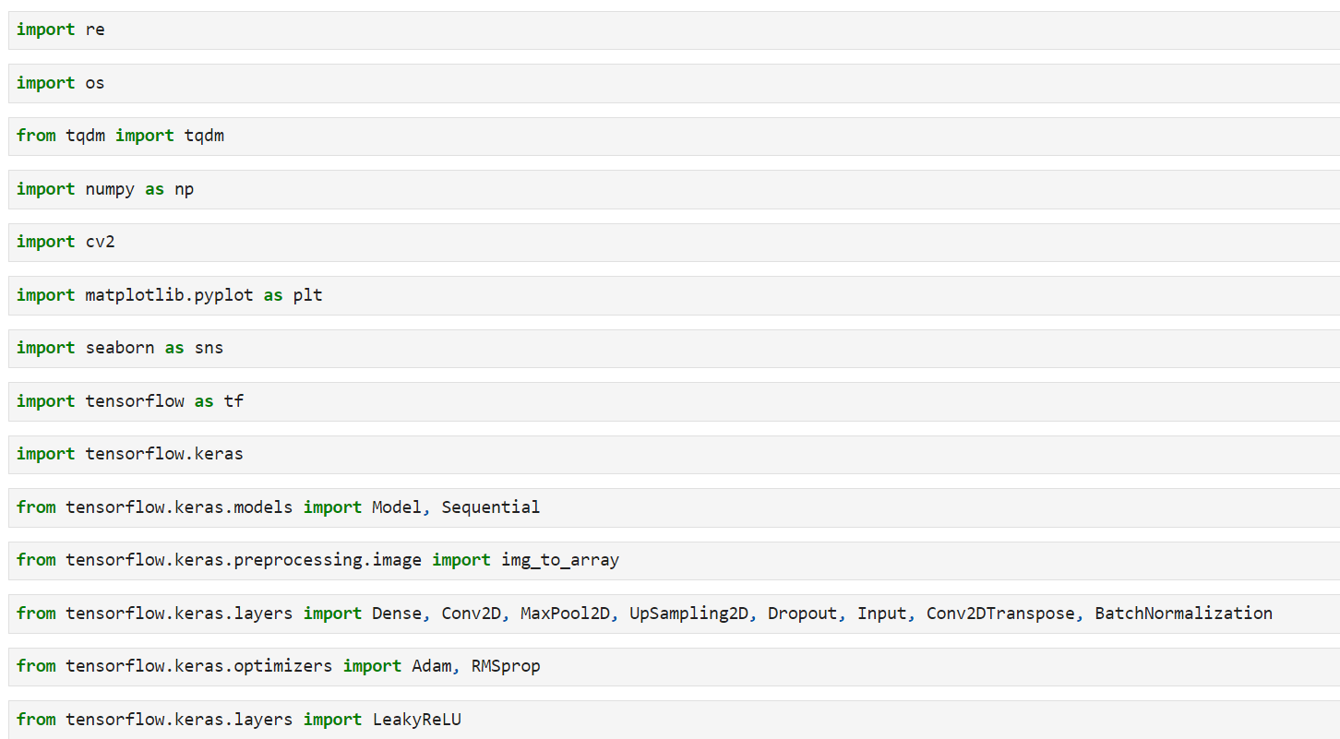
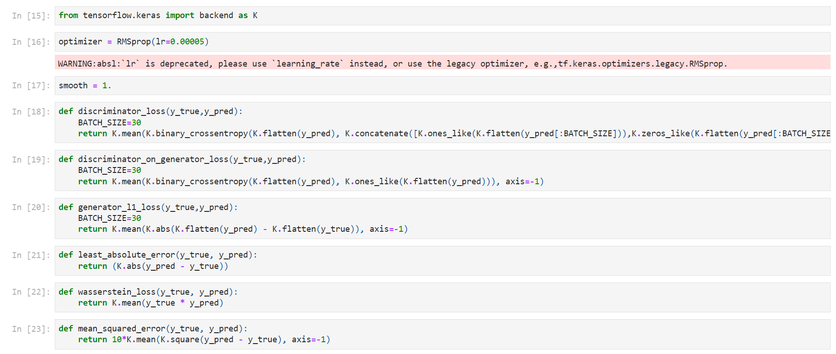
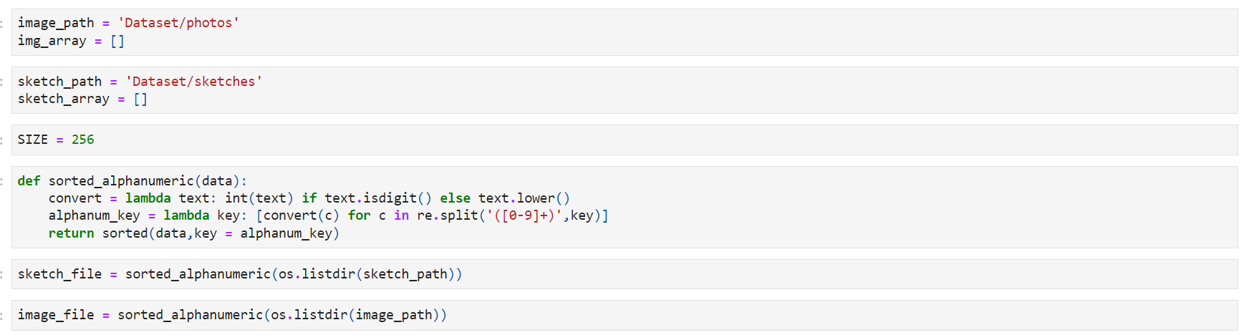

REFERENCES

- Eman S. Sabry,Salah S. Elagooz,Fathi E. Abd El-Samie,Walid El-Shafai,Nirmeen A. El-Bahnasawy,Ghada M. El-Banby,Abeer D. Algarni,Naglaa F. Soliman,Rabie A. Ramadan Image Retrieval Using Convolutional Autoencoder, InfoGAN, and Vision Transformer Unsupervised Models IEEE Access, 2023
- Hayato Arai,Yuto Onga,Kumpei Ikuta,Yusuke Chayama,Hitoshi Iyatomi,Kenichi Oishi Disease-Oriented ImageEmbedding With Pseudo-Scanner Standardization for Content-Based Image Retrieval on 3D Brain MRI IEEE Access, 2021
- Luqing Luo,Zhi-Xin Yang,Lulu Tang,Kun Zhang An ELM-Embedded Deep Learning Based Intelligent Recognition System for Computer Numeric Control Machine Tools IEEE Access, 2020
- Jahanzaib Latif,Chuangbai Xiao,Shanshan Tu,Sadaqat Ur Rehman,Azhar Imran,Anas Bilal Implementation and
- Use of Disease Diagnosis Systems for Electronic Medical Records Based on Machine Learning: A Complete Review IEEE Access, 2020
- Mohamad M. Al Rahhal,Yakoub Bazi,Norah A. Alsharif,Laila Bashmal,Naif Alajlan,Farid Melgani Multilanguage Transformer for Improved Text to Remote Sensing Image Retrieval IEEE Journal of Selected Topics in Applied Earth Observations and Remote Sensing, 2022
- Mohamad M. Al Rahhal,Yakoub Bazi,Norah A. Alsharif,Laila Bashmal,Naif Alajlan,Farid Melgani Multilanguage Transformer for Improved Text to Remote Sensing Image Retrieval IEEE Journal of Selected Topics in Applied Earth Observations and Remote Sensing, 2022
- Tengfei Wu,Lu Leng,Muhammad Khurram Khan,Farrukh Aslam Khan Palmprint-Palmvein Fusion Recognition Based on Deep Hashing Network IEEE Access, 2021
- Zhenghang Yuan,Lichao Mou,Qi Wang,Xiao Xiang Zhu From Easy to Hard: Learning Language-Guided Curriculum for Visual Question Answering on Remote Sensing Data IEEE Transactions on Geoscience and Remote Sensing, 2022
- Arka Ujjal Dey,Ernest Valveny,Gaurav Harit EKTVQA: Generalized Use of External Knowledge to Empower Scene Text in Text-VQA IEEE Access, 2022.
- Naushad Varish,Arup Kumar Pal,Rosilah Hassan,Mohammad Kamrul Hasan,Asif Khan,Nikhat Parveen,Debrup Banerjee,Vidyullatha Pellakuri,Amin Ul Haqis,Imran Memon Image Retrieval Scheme Using Quantized Bins of Color Image Components and Adaptive Tetrolet Transform IEEE Access, 2020.
Conference/Journal article Mail Copy- Proof if applicable
Conference Certificate- if any

(Not to mention page number to this proof sheet)

